Graduate/Professional Student Loan
To Do List Guidance
Check your To Do List in My Akron’s Student Center to see which item(s) are outstanding. The University of Akron will receive notification when you complete the outstanding requirement(s). Please allow 5 business days for the To Do List to be updated.

The following items can be completed at www.studentaid.gov “In School” tab.

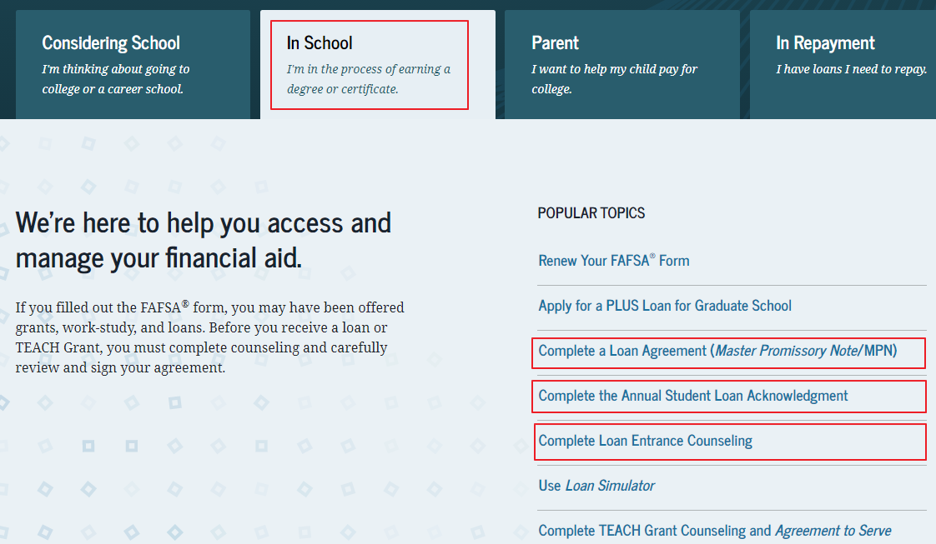

If Entrance Counseling is needed for an Unsubsidized Loan and/or Grad PLUS Loan:
- Click on Complete Entrance Counseling and Log in with YOUR FSA ID and Password. (Don’t use your parents, use yours!) Complete the Entrance Counseling process.

If Annual Student Loan Acknowledgement is needed:
- Click on Complete Annual Student Loan Acknowledgement and Log in with YOUR FSA ID and Password. (Don’t use your parents, use yours!) Complete the Annual Student Loan Acknowledgement. This is requirement must be completed each year effective with the 2021-2022 aid year.

If a Master Promissory Note is needed for Unsubsidized Stafford Loan or Direct PLUS Loan:
- Click on Complete A Loan Agreement (Master Promissory Note/MPN).
- Select I’m a Graduate/Professional Students
- Log in with your FSA ID

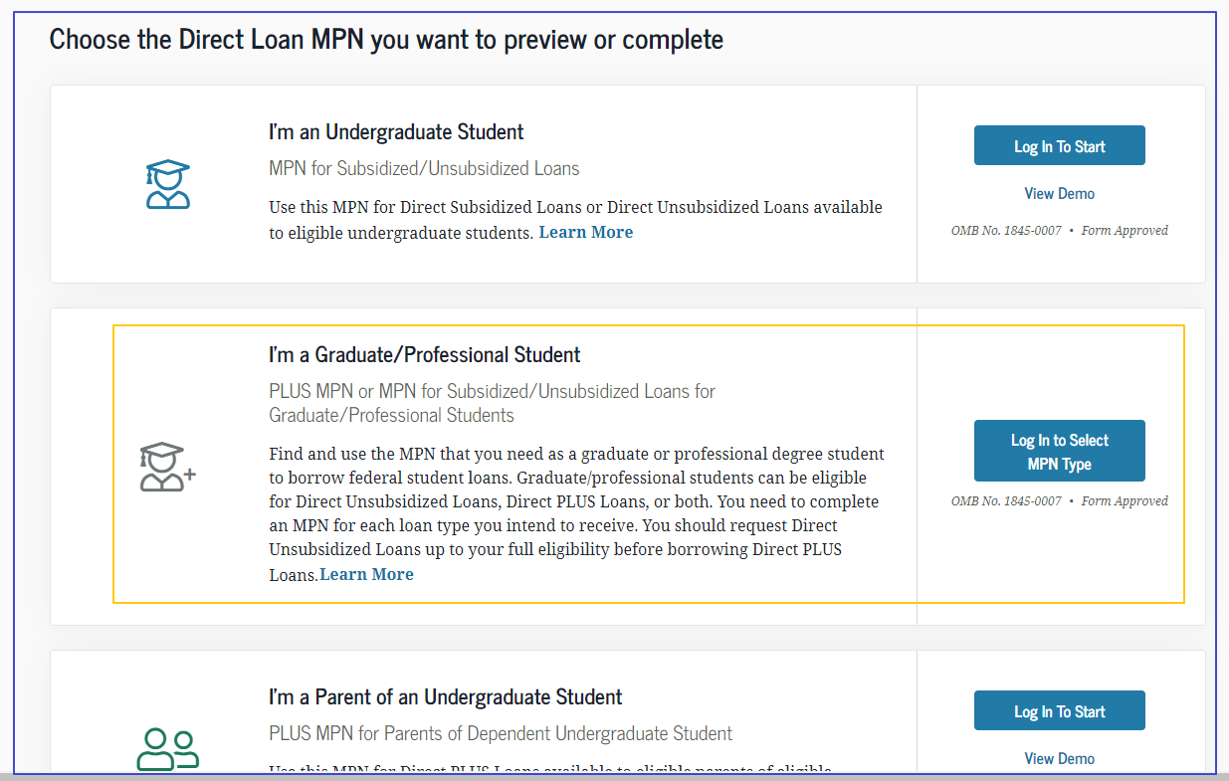
- Select the appropriate Promissory Note for the type of Loan you are borrowing.
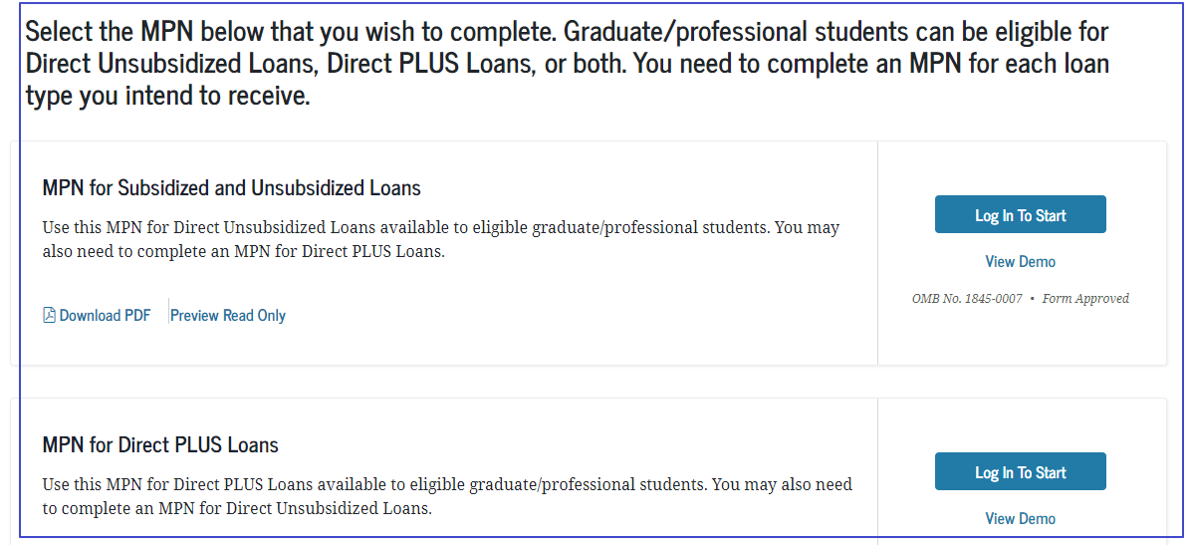
If PLUS Credit Counseling is needed:
- Click on Apply for Aid
- Click on Complete PLUS Credit Counseling. This step is required if you have been denied a PLUS Loan and obtained an Endorser (Co-signer). The Endorser will need to log in and complete the Endorser Addendum to approve the loan amount.
- Log in with your FSA ID.

